**Standards to be followed while preparing the content:**

1. The question should start with a number, then a period and a space to be included and please do not include semicolon after the question number.



1. Include the complexity tag below the question. The links to complexity tags are included in the github

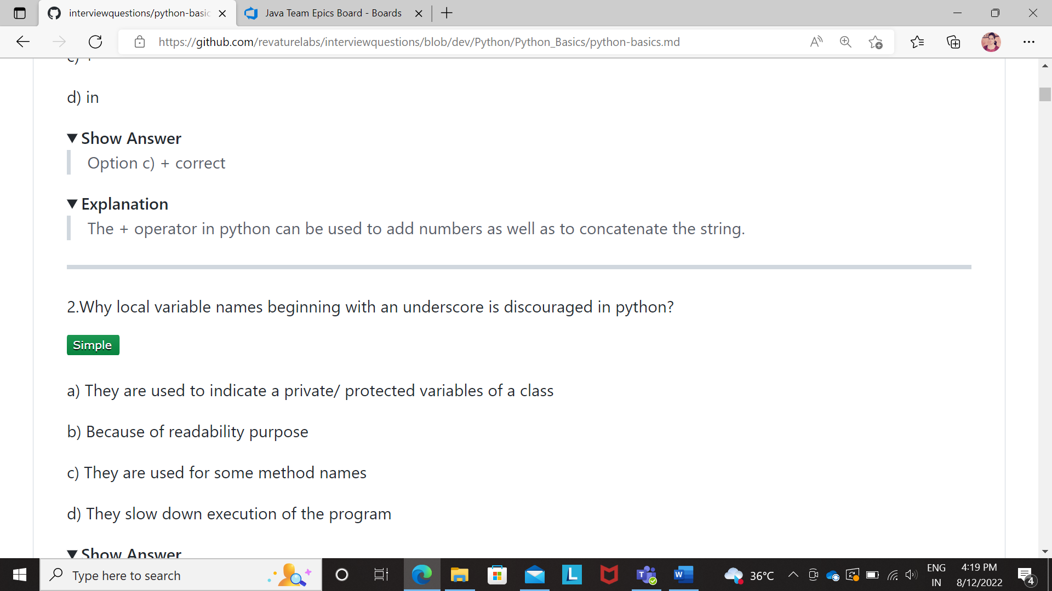



1. Please do not include a separate word as “Ans” or “Answer” below the “Show Answer” section. Type your answers directly below the “Show Answer” section. Also, include a vertical bar in-front of the answer.



1. Please do not include the answer and explanation together in the “Show answer” section. “Show answer” section should answer the question and “Explanation” section should explain why we chose that option as the answer. Also, include a vertical bar in-front of the explanation.



1. Please remove bullet points in both “Show answer” and “Explanation” sections if it is a single point. Include bulletins if there are more than one point.
2. Kindly have a check on the color and the spacing of the codes. You could use the respective language name in the github using “---” infront of t to correct the color and spacing.

Also, highlight the code block

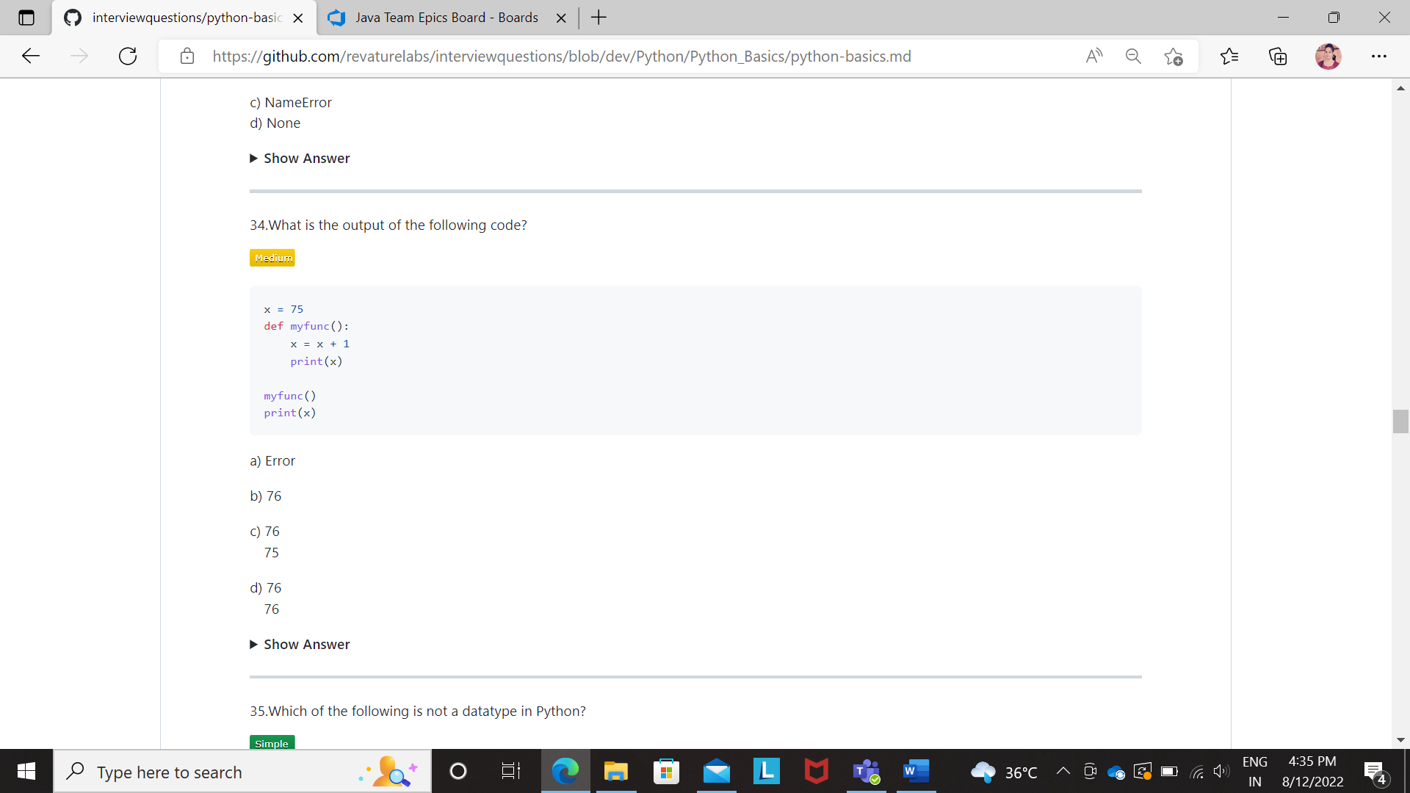



1. For MCQ based questions, in the “Show answer” section, mention the answer along with the option.



1. Please include a horizontal line at the end of every question to show the segregation and for a better viewability.



1. All the keywords, methods names, function names, expressions and related should be highlighted.

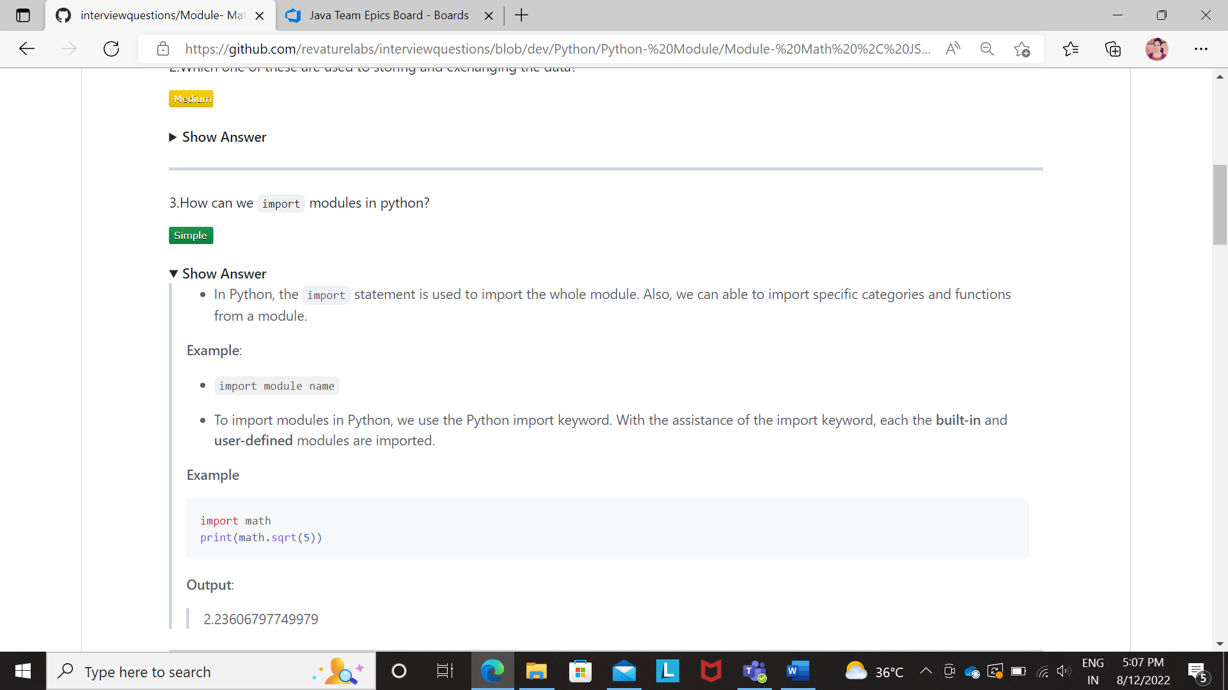



1. Kindly review the content through Grammarly app or grammar related apps to avoid grammatical errors.